

**EE2026 Digital Fundamentals**

Semester 2 2017/2018

**FPGA Design Project:**

**Real-Time Audio Effects**

**Project Report**

**Lab Session: Friday**

|  |  |
| --- | --- |
| Name | Student # |
| Saif Uddin Mahmud | A0170896N |
| Muhammad Harun Bin Abdul Rashid | A0164598L |

**Section 1:**

**Project summary**

This project was worked entirely on the Basys 3 FPGA board. By connecting 3 external components to it, the PmodMIC3, PmodDA2 and PmodAmp2, we would be able to feed it audio input and hear its output. This project makes use of the various switches and other functions on the board to vary and produce different types of audio outputs.

**Section 2:**

**Project Task 2A: Microphone-Speaker System with Delay**

Table 1 below shows the features demonstrated for this project task and the inputs required by the user.

|  |  |  |  |  |
| --- | --- | --- | --- | --- |
| No. | Feature | Input | Description | Output Display |
| 1 | Replay audio signal | SW14 to SW15 | -Set as 2-bit value  - Initial state of SW15 and SW14 is ‘00’ for no delay.  - Flick either switches or both to get variable delay (1 – 3s) | Playback of audio signal with or without delay |

**Table 1: Description of feature and how to activate it**

This project task requires us to output the input audio signal by 1 second. As an improvement to this, we decided to have variable delays ranging from 1 to 3 seconds, as described in Table 1 above.

The system makes use of a circular buffer and writes ahead of read. The user’s input for delay determines how far away. The indices were calculated keeping the 20kHz clock in mind. Usage of any other clocks of different frequencies will result in recalculations and adjustments to the code.

With reference to the code snippet in figure 1 below, the delay input is assigned to switches SW[15:14] (which were renamed to varDelay[0] and [1] respectively). The main objective of this task is to get a 1 second delay which means varDelay has to be set to 2’b01 by the user to achieve this. For a longer delay, it could be set to, for example,

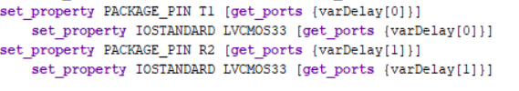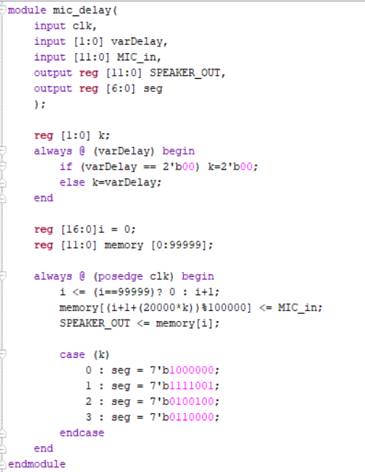

**Figure 1 : Top is code snippet of task 2A and bottom is assignment of varDelay**

**Section 3:**

**Project Task 2B: Electronic Musical Instrument**

Table 2 below shows the different features described by this task and the required inputs by the user.

|  |  |  |  |  |
| --- | --- | --- | --- | --- |
| No. | Feature | Input | Description | Output Display |
| 1 | Output different musical notes | SW[3] | C4/do note | Playback of musical notes without any delay |
| 2 | SW[4] | D4/re note |
| 3 | SW[5] | E4/mi note |
| 4 | SW[6] | F4/fa note |
| 5 | SW[7] | G4/sol note |
| 6 | SW[8] | A4/la note |
| 7 |  | SW[9] | B4/ti note |
| 8 | (extra feature)  Increases pitch | SW[10] | All notes played at X5 (X is note) | Playback of a higher-pitched variant of musical notes |
| 9 | SW[11] | All notes played at X6 (X is note) |

**Table 2: Description of various musical notes and how to activate it**

The main objective of this project task was to create a basic musical instrument that could play a musical scale from the ‘do’ to ‘ti’ note, using the switches on the FPGA. At any point, only one switch could be on so that only 1 note is heard at any point in time. With reference to Table 2 above, we have designated switches SW[9:3] for the musical scale.

The frequencies given in the project task was the notes played at X4 or middle notes. Thus, as an improvement, we have decided to designate an extra 2 switches, SW[11:10] to vary the current pitch so that the notes can be played at either X5 or X6 pitches. These were also listed in Table 2 above.